**Cameroon country profile**

Published

22 October 2018

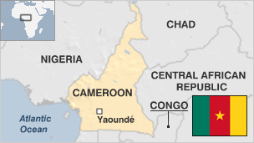

**Cameroon is often known as "Africa in miniature" because of its geographical and cultural diversity.**

The Central African country has one of the highest literacy rates on the continent, but its economic progress has been hampered by corruption and decades of authoritarian rule.

Created in 1961 by the unification of a British and a French colony, the modern state of Cameroon has also struggled to find peace and unity.

Internally, there are tensions over the two mainly English-speaking south-western provinces. A secessionist movement emerged in the 1990s, and turned into an insurgency in 2016.

The mainly-Muslim far north has been drawn into the regional Islamist insurgency of the Boko Haram group.

* Read more [country profiles](http://news.bbc.co.uk/1/hi/country_profiles/) - Profiles by [BBC Monitoring](http://bbc.co.uk/monitoring)

**President: Paul Biya**

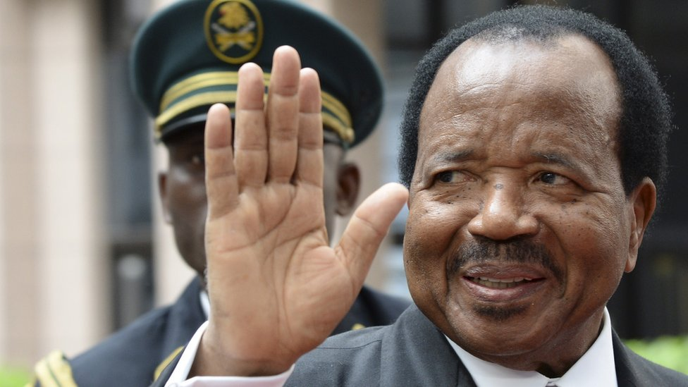image copyrightGetty Images

In power since 1982, Paul Biya is one of Africa's most entrenched leaders.

Parliament passed a controversial amendment in 2008 allowing him to run for office again, and he won new seven-year terms in 2011 and 2018 in votes marred by irregularities.

His party, the Cameroonian People's Democratic Movement (RDPC), has won landslide majorities in every parliamentary election since 1992.

Before becoming president, Mr Biya spent his entire political career in the service of President Ahmadou Ahidjo, becoming prime minister in 1975.

In 1983 he accused Mr Ahidjo of organising a coup against him, forcing the former president to flee the country.

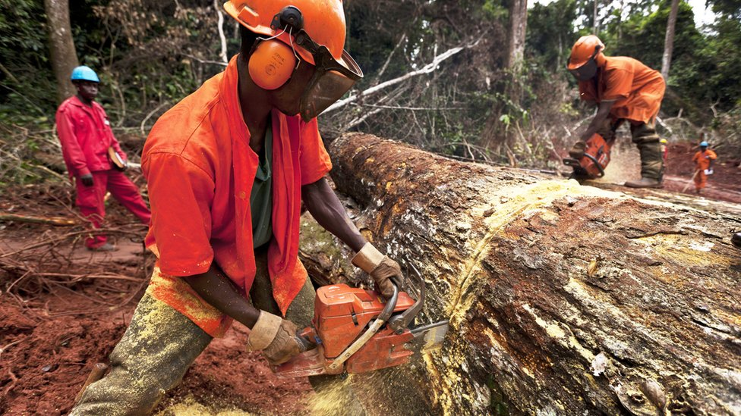image copyrightGetty Images

image captionCameroon has extensive timber reserves

State-run CRTV operates alongside dozens of private radio and TV stations.

Journalists reporting on sensitive subjects risk legal action, says Freedom House.

Amid protests in English-speaking regions, internet access in these areas has been disrupted.

# Cameroon profile - Timeline

Published

22 October 2018

## A chronology of key events:

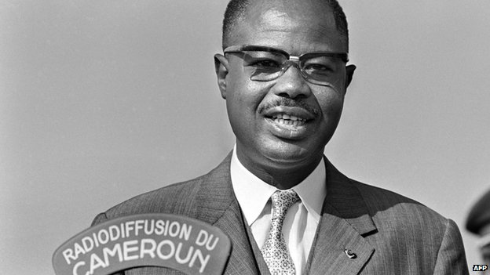image copyrightAFP

image captionAhmadou Ahidjo was Cameroon's first post-independence leader

**1520** - Portuguese set up sugar plantations and begin slave trade in Cameroon.

**1600s** - Dutch take over slave trade from Portuguese.

**1884** - Cameroon becomes the German colony of Kamerun.

**1911 -** Under the Treaty of Fez - signed to settle the Agadir Crisis Franco-German conflict over Morocco - France cedes territories to the east and south to Cameroon.

**1916** - British and French troops force Germans to leave Cameroon.

**1919** - London Declaration divides Cameroon into French (80%) and British administrative zones (20%). The British zone is divided into Northern and Southern Cameroons.

## Independence

**1960** - French Cameroon granted independence and becomes the Republic of Cameroon with Ahidjo as president.

**1961** - Britain's Cameroons colonies divide between Cameroon and Nigeria after a referendum. A large-scale insurrection mars the country's first years of independence until it is put down in 1963 with the help of French forces.

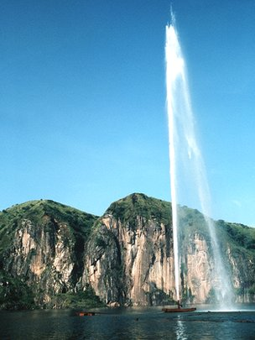

image captionA 1986 release of carbon dioxide from Lake Nyos - seen being degassed in 2001 - killed 1,700 people

**1966** - National Cameroonian Union formed out of six major parties and becomes the sole legal party.

**1972** - Cameroon becomes a unitary state following a national referendum and is renamed the United Republic of Cameroon.

## Paul Biya era

**1982** - Prime Minister Paul Biya succeeds President Ahidjo, who resigns.

**1983** - Mr Ahidjo goes into exile after President Biya accuses him of masterminding a coup.

**1984** - President Biya elected to his first full term as president, changes the country's name to the Republic of Cameroon.

**1986** - Discharge of poisonous gases from Lake Nyos kills about 1,700 people.

**1992** October - Paul Biya re-elected in Cameroon's first multi-party presidential election.

**1994** - Fighting between Cameroon and Nigeria flares up over disputed oil-rich Bakassa Peninsula.

**1996** January-May - Further Cameroonian-Nigerian border clashes.

**1996** May - Cameroon and Nigeria agree to UN mediation over Bakassa Peninsula.

**1997** May - President Biya's party, the Cameroon National Democratic Movement (formerly the National Cameroonian Union), wins a majority of seats in parliament amid allegations of irregularities.

**1997** October - President Biya re-elected in ballot boycotted by main opposition parties.

## Corruption

**1998** - Cameroon classed as the most corrupt country in the world by business monitor Transparency International.

**2000** June - World Bank approves funding for oil and pipeline project in Cameroon and Chad, despite strong criticism from environmental and human rights activists.

**2000** October - Catholic Church in Cameroon denounces corruption, saying it has permeated all levels of society.

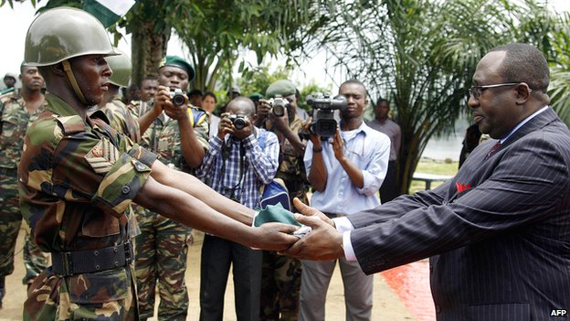image copyrightAFP

image captionNigerian soldiers withdrew from the Bakassi Peninsula in 2006, four years after the International Court of Justice ruled in favour of Cameroon in the two countries' territorial dispute

**2001** June - Fears for Cameroon's environment increase, with Global Forest Watch reporting that 80% of the country's indigenous forests have been allocated for logging.

**2001** October - Growing tension between government and separatists lobbying on behalf of country's five million English-speakers. Unrest results in three deaths, several arrests.

## Bakassi ruling

**2002** October - Ruling by International Court of Justice gives sovereignty of oil-rich Bakassi Peninsula to Cameroon. But Nigeria, whose forces occupy the area, rejects the ruling.

**2006** June - Nigeria agrees to withdraw its troops from the Bakassi Peninsula to settle its long-running border dispute with Cameroon.

The Paris Club of major lending nations agrees to cancel almost all of Cameroon's $3.5bn debt.

**2007** November - Suspected Nigerian militants kill 21 Cameroon soldiers in Bakassi Peninsula.

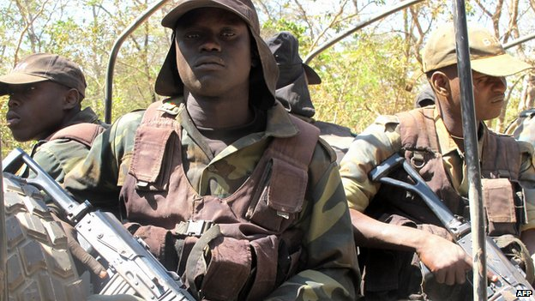image copyrightAFP

image captionCameroon vowed a tough approach on poaching after hundreds of elephants were massacred in Bouba Njida National Park in 2012

**2008** February - A nationwide transport strike in protest at fuel costs turns into a series of anti-government demonstrations in the capital, Yaounde, leaving at least 17 dead.

## Constitution amended

**2008** April - Parliament amends the constitution to allow President Biya to run for a third term in 2011. The opposition condemns the move as a "constitutional coup".

**2011** January - Cameroon secures Chinese loan to build deep sea port at Kribi, terminal of an oil pipeline from Chad.

**2011** October- Paul Biya wins a landslide re-election as president, officially taking 78% of the vote. His opponents reject the result, alleging widespread fraud.

**Boko Haram incursions**

**2013** February - A French family of seven is kidnapped by the Islamist group Boko Haram near the Nigerian border, and released two months later.

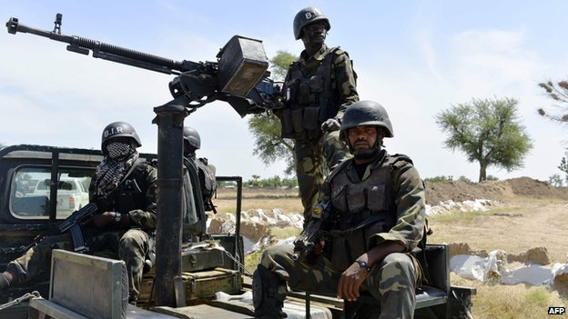image copyrightAFP

image captionCameroon troops have been deployed to counter Boko Haram raids from northern Nigeria

**2014** January - A French priest kidnapped by Islamist gunmen in the far north of Cameroon in November is freed.

**2014** May - Cameroon deploys about 1,000 troops to the border with northern Nigeria to counter a rising threat of incursions and kidnappings by Boko Haram.

**2014** October - Twenty-seven hostages kidnapped by Boko Haram in Cameroon earlier in the year, including 10 Chinese workers and the wife of the deputy prime minister, are freed.

**2015** January - Chad pledges military support for Cameroon against Boko Haram.

## Anglophone protests

**2016** November - Violent protests against the imposition of French in Anglophone parts of Cameroon.

**2017** March-November - Unrest as Anglophone minority in north- and south-west regions continue protest action against perceived marginalisation.

**2018** March - Two soldiers are killed in clashes with separatists in Anglophone areas, the latest of several deadly incidents in an insurgency related to the campaign for greater autonomy.

**2018** October - President Paul Biya wins a seventh term in a vote marked by low turnout and voter intimidation.